INDEX
S.NO. | PRACTICAL | PAGE NO. | SIGNATURE
1. | Write a program to find maximum between three numbers.
2. | Write a program to check whether a number is positive, negative or zero.
3. | Write a program to check whether a character is alphabet or not.
4. | Design an application to input marks of 5 subjects. calculate percentage and grade according to following :-  Percentage >= 90% : Grade A  Percentage >= 80% : Grade B  Percentage >= 70% : Grade C  Percentage >= 60% : Grade D  Percentage < 60% : Grade F
5. | Design an application to input basic salary of an employee and calculate its gross salary according to following :  Basic Salary <=10000: HRA = 20%, DA=80%  Basic Salary <=20000: HRA = 25%, DA=90%  Basic Salary >20000: HRA = 30%, DA=95%
6. | Write a program to swap two numbers using bitwise operator.
7. | Write a program to create simple calculator using select case.
8. | Write a program to find sum of all natural numbers between 1 to n.
9. | Write a program to find first and last digit of any number.
10. | Write a program to enter any number and print its reverse.
11. | Write a program to enter any number and Check whether the number is palindrome or not.
12. | Write a program to print Fibonacci series up to n terms.
13. | Write a program to print all negative elements in an array.
14. | Design the digital watch using timer control.
15. | Design an application that accepts the item name from the user and add it to a listbox and combobox.
16. | Create an application that offers various food items to select from checkboxes and a mode of payment using radio button. It then displays the total amount payable.
17. | Design an application to input electricity unit charges and calculate total electricity bill according to the given condition:  For first 50 units Rs.0.50/unit  For next 100 units Rs. 0.70/unit  For next 100 units Rs.1.20/unit  For unit above 250 Rs.1.50/unit  An Additional surcharge of 20% is added to the bill.
18. | WAP for temperature conversion using radiobutton.
19. | WAP to change the back color of any control using scrollbar.
20. | Design the form that calculates Sum, Multiplication, Division and Subtraction of two numbers.
21. | WAP to find the number is even or odd.
22. | Design the following application using radiobutton and checkbox.  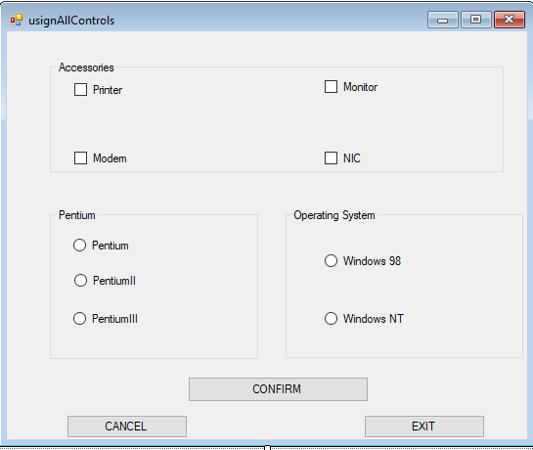
23. | Design an application to create the payroll form shown below. Number of hours must be entered as well as the appropriate rate.  Gross salary=rate * hours  Net salary= gross salary – deductions
24. | Develop an application which is similar to login form
25. | WAP that implements the concept of Inheritance.
26. | Design the form to perform insert, update, delete operation on MS Access database using ADO.net.
27. | Design the form to display contents of data table in DataGridView from your database.
28. | Design the form to input radius of a circle and find its circumference and area.
29. | Design the form to input length in centimeter and convert it into meter.
30. | Design the form to input temperature in Celsius and convert it into Fahrenheit.
31 | Design the form to input Principle amount, Time, Rate and calculate Simple Interest and Compound Interest show result information in msgbox.
32. | Design the following form using horizontal scrollbar. In this when user click on a particular scrollbar then back color of shape will be changed to red, green and blue color.
33. | WAP for Exception handling of throwing an exception when dividing by zero condition occurs during arithmetic operation.
34. | WAP to demonstrate handling of multiple exceptions generated in program.
35. | Write a program to launch a rocket using picturebox and timer control.
36. | Create an application to implement the working of the context menu on textbox.

